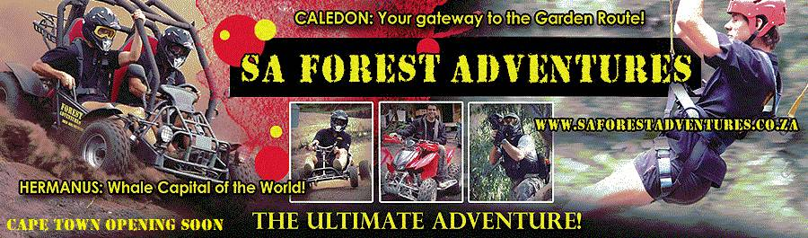

TEAM BUILDING PRODUCTS

DRUMMING

R350pp

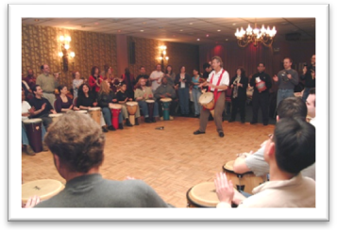

Drums

2 facilitators

60-90 min session

Each team member will be given an African drum called a Djembe. The facilitator will teach you the right technique to create the perfect rhythm by working together as a team. A great non physical activity

Creative Outlet

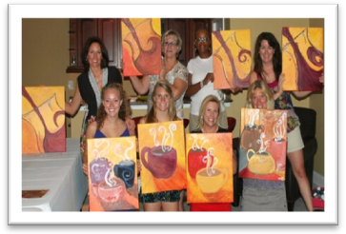

Canvas painting - R350pp

Canvas

Paint

Brushes

2-3 hours

Each team member will receive his/her own canvas and brushes. The art facilitator will give you an assignment to complete according to your own imagination. This is a fun exercise and it will give you a little insight into your colleague’s imagination. You will be able to take your painting home.

Sculpture - R250pp

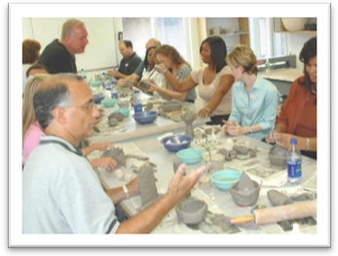

Clay

Sculpture tools

2-3 hours

Each team member will get the same amount of clay. According to the assignment, you have to use your clay to sculpt something fantastic. Getting your hands dirty is the best way to get the creative juices flowing. Your creation could look great on your desk at work

One Canvas - One team - R395 pp

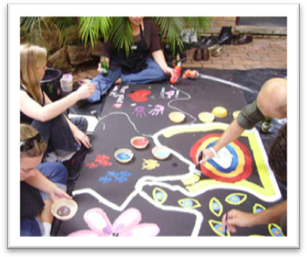

One big canvas

Paint

Brushes

2-3 hours

The whole team will have to work together on this one. A good planning and strategy session will be essential before any paint sees the canvas. Portray the assignment given as a team, to create a master piece that could be exhibited in the office.

TREASURE HUNT

From R250pp

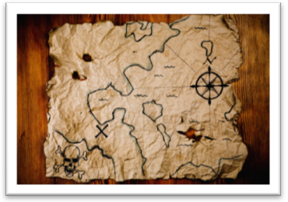

The group will be split into teams. Each team will receive a map of the area. Teams must find the treasure but have to complete different tasks and obstacles to get to the treasure. It is a great day out of the office and a fun way to get to know your colleagues better.

Ready Steady Cook

R395pp

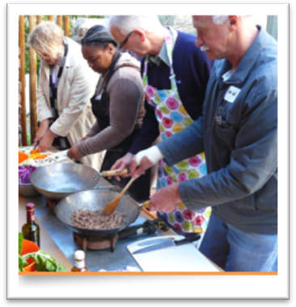

All cooking equipment

Ingredients

2 hours

The group will be split into teams. Each team will have a cooking station complete with utensils, stoves and all implements needed. With a limited time, limited ingredients and a whole lot of creative thinking, each team must create a 3 course meal with the ingredients provided and within the time allowed. This activity can get extremely competitive and the teams will be judged on presentation, taste, team work and imagination.

Potjie Kos Competition

R450

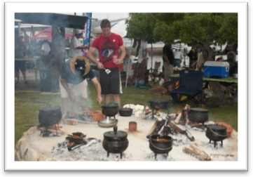

All cooking equipment

Ingredients

3 hours

The group will be split into teams. Each team will have a cooking station with all the equipment needed to prepare your pot. Fires and hot coals will be available. A general ‘pantry’ station with all the fresh vegetables and spices will be set up. Each team will be judged on various criteria, from cleanliness to taste. The final product will be the dinner at the end, and the group will get a chance to enjoy each others pots.

AMAZING RACE

From R350 pp

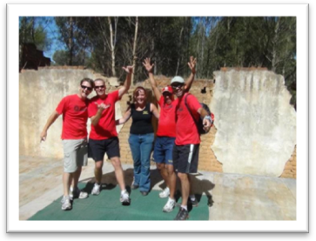

This activity is extremely versatile and can be done in any town or place. The group will be spilt into teams. Each team will receive a clue or ‘route info’ that will take them to various places. When the team arrives at the destination, they have to perform a task. Ones this task is complete, the next clue will be handed to them.

This event can run for anything from 2 hours to 2 days. It is a great way to learn about various places and it can become very competitive.

OUTCOMES BASED TEAM BUILDING

From R250pp

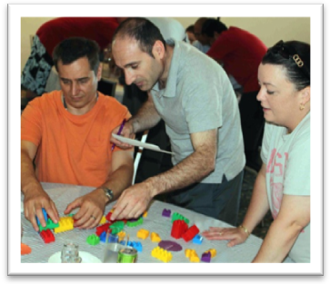

If you notice a problem in your group, whether it is a trust issue, communication problems, problem solving or any other issue, it can easily be solved with outcomes based teambuilding. Various games are given to the team to play and puzzles to solve. The reaction and response of each team member will be noted by the facilitator and a report is given to the team. It is a fun way to get to know your colleagues and to find out how they think and react to different situations.